|  |  |  |
| --- | --- | --- |
| **Safety** | **Version:** 5.1.23 | **ID:** SE-050 |

# Abstract

This is the process to follow when entering in a safety incident through Freshdesk.

# Process

1. Within Freshdesk, you will start by creating a new ticket. Click on the **New+** button in the top right corner of the screen and then select **New ticket:**

1. A safety incident ticket is created using a template:
   1. If not already open, expand the additional tools menu on the right by clicking the square button with the arrow.
   2. Click in the dropdown to “Pick a template”.
   3. Scroll down the template list and select the template called **“Safety Incident Report”**.

1. Before filling out the ticket, be sure to have the proper “sub-tickets” selected that are most related to the situation. You can have more than one option selected, if applicable.  
     
   For example, if a technician or driver reports they have a flat tire, it would still be grouped under the “Motor Vehicle Accident” sub-ticket because it is most closely related to the incident.  
     
   **Note:** These sub-tickets (called “Child tickets” in Freshdesk) are important to have selected, if applicable, so that they can be dealt with by the proper department.

1. In the example ticket below, the steps to fill out a ticket are as follows:  
   Example: A technician’s van hits a customer’s mailbox and damages it.
   1. Select the sub-tickets for the “Property Damage” of the customer’s mailbox, and then “Motor Vehicle Accident” because the technician’s vehicle was involved in the incident.
   2. The “Contact” of the ticket is whoever is creating the ticket on behalf of the incident. So if YOU are the one creating the ticket, YOUR name will be the Contact.
   3. If the incident involves a customer, enter in the Cargas Account Number of the customer involved.  
      **NOTE:** If the incident involves an employee injury, **DO NOT** include the Cargas Account Number on the ticket. You can enter “0” (zero) into the field if there is an employee injury.   
      This is for employee privacy, as Freshdesk automatically copies the ticket to the Cargas Account if there is an account number filled in.
   4. The Subject of the ticket would be the brief statement of what the incident was. Think of this as the subject of an email and try to be specific to the situation and not just a general title such as “Property Damage”.
   5. Leave the Priority level as is. “Low” does not mean the situation is not important, it is related to the amount of time a ticket can remain open.
   6. Choose the Company Division that best fits the incident.

1. Go through the rest of the ticket, filling out the fields as they are labeled. Try your best to get in as much information as possible. You can enter “N/A” into fields that are not applicable and not required (does not have a red * next to it).  
   If a field is pre-filled, leave it as is.
2. Fill out the Description section with **AS MUCH** information about the incident as possible. All that you know of the incident should be placed here to better help the process of filing and completing a safety investigation.

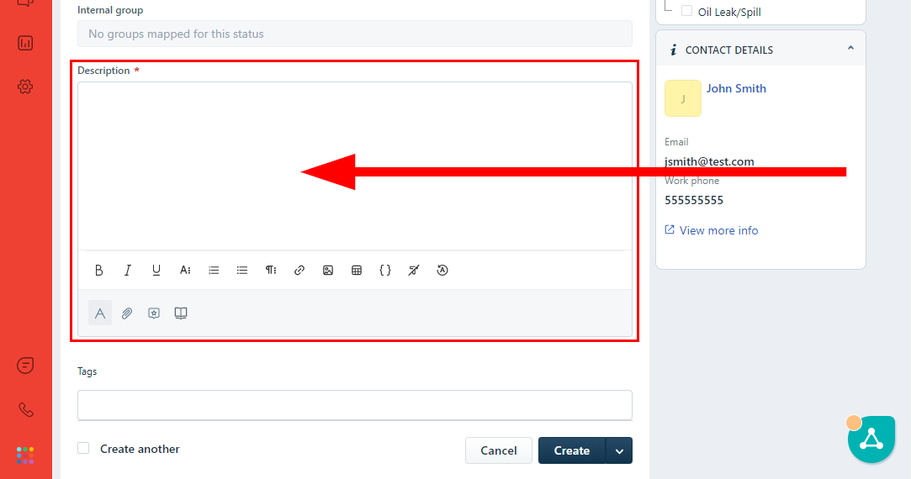

1. When all of the fields have been filled and you are ready to submit the ticket, select the **Create** button.

