Emergency Action Plan

154 Admiral Street Bridgeport, CT 06605

**Purpose**

Santa Energy Corporation is committed to the safety and health of our employees, customers, and the public. The purpose of this Emergency Action Plan is to clearly define actions to be taken in the event of an emergency on site at Santa Energy Corporation. This plan is focused on the 154 Admiral Street, Bridgeport CT location.

**Contact Employees**

If there are questions or concerns on what an employee’s role is based upon this emergency action plan, the employee can request information from the following employees:

**Sara Agosti** – *Safety Officer*

[agostis@santaenergy.com](mailto:agostis@santaenergy.com)

475-319-5669

**Stephen Santa** – *Director of Operations*

[santasb@santaenergy.com](mailto:santasb@santaenergy.com)

203-770-3338

*This plan is reviewed and approved by management of Santa Energy Corporation annually.*

**Reporting Emergencies**

In the event of an emergency, Santa Energy Corporation and its employees will use audio alarms and word of mouth to alert others of the emergency situation.

**Audio Alarm Systems**

Santa Energy has numerous audio alarm notification systems to be put in place in case of an emergency.

*Phone alarm system*

Santa Energy’s phone system has an emergency feature in which anybody in the building can connect to the loudspeaker to report an emergency. To do so:

1. Click on “Page” button on phone screen
2. Wait for beep, approximately 3 seconds
3. Speak loud and clear to report the event to office staff
4. Hang up when completed

*Voice*

If other audio alarms fail in the event of an emergency, the employee who discovers the emergency will use their voice to alert others in the facility of the emergency situation.

*Other Notification Requirements*

In the event of a medical emergency or another emergency in which FD, EMS or PD will arrive on scene, after calling 9-1-1, you must contact a front desk employee or the Safety Officer to ensure swift action upon emergency personnel’s response.

**Shelter In Place**

In some emergency events, a shelter in place will be required. In the event of a shelter in place, all employees will stay inside the building in a safe location. If the employee is not currently in the building, the employee must head to the closest, safe location.

A shelter in place situation will conclude when the appropriate authorities alert Santa Energy Corporation that it is safe to conclude.

**Emergency Evacuation**

Meeting Locations

The primary meeting location is on Admiral Street in the parking lot to the left of the maintenance garage and behind Ben’s building.

If the primary meeting location is unsafe to access, the secondary meeting location should be used. This location is at the end of Admiral Street, underneath the highway bridge.

*Accounting for Employees During Evacuations*

The building at 154 Admiral Street has been broken into evacuation groups. Upon arrival at the designated meeting location, predetermined group leaders will take attendance of their group members. If any group members are not accounted for, the group leader will ensure the proper personnel have been notified.

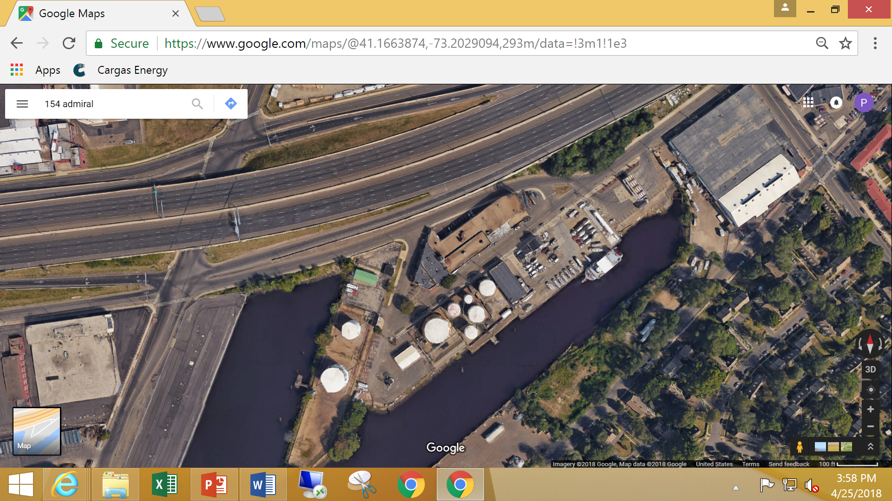

The starred locations indicate the primary and secondary emergency meeting locations.

**Evacuation Groups**

The building is broken into groups for evacuation routes and accountability. In every group there will be a group leader as well as a backup leader who will clear their work area as well as take account of any potential missing persons in their group.

If there is a visitor in the building, they will be escorted out of the building with the person that they are visiting.

*Admin Group*

The admin group will exit through the cafeteria and down the back fire exit stairs, through the library to the Admiral Street exit. This is Exit #6 to Exit #2.

The Human Resources Manager will clear the Conference/Training Room, Admin offices and cafeteria.

*Credit & Accounting Group*

The Credit and Accounting team will exit through the cafeteria, down the back exit stairs and through the library to the Admiral Street exit. This will be Exit #6 to Exit #4.

The Credit Manager will clear the ladies’ restroom, close the doors in the hallway and clear the second-floor storage area.

*Inland Group*

The Inland group will exit down the main front entrance stairway and exit to Admiral Street. This will be Exit #5 to Exit #1.

The Group Leader for Inland Group will clear the inland conference, coffee station, knock on the men’s restroom and copier area.

*West End Group*

The West End Group will exit down the side stairs and exit out the front main entrance onto Admiral Street. This will be Exit #8 to Exit #1. The fire escape window can be used if there is no other way out.

The IT Help Desk Admin will clear the West End offices and server room.

*Buckley & Sales Group*

The Buckley and Sales Group will exit via the back emergency exit stairway to Harbor Street, then gather at the Admiral Street meeting location. This will be Exit #7.

The Group Leader will clear all offices and cubicles on the way out.

*Service Group*

The Service Group will exit out of the back emergency exit in the Service Conference Room and travel to the Admiral Street Meeting location.

The Service Manager will sweep the area on their way out.

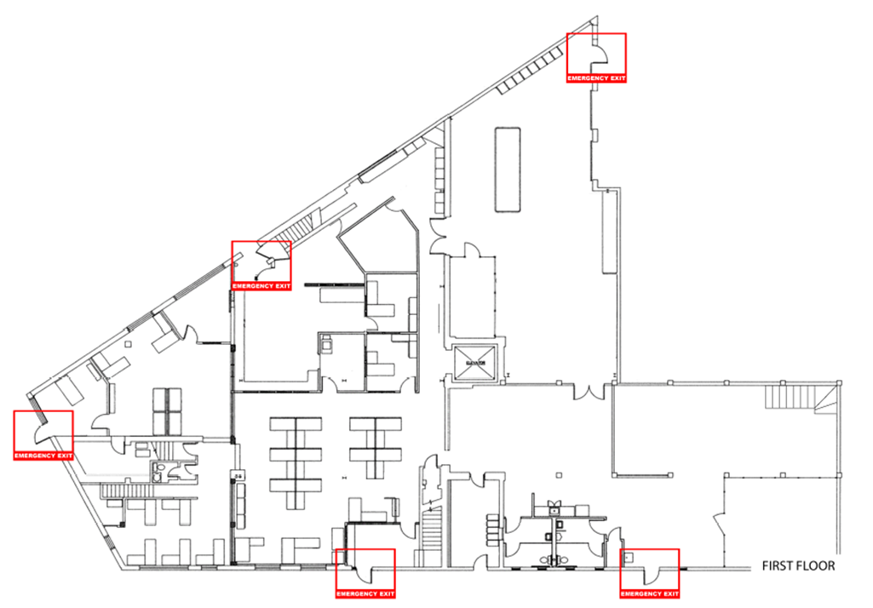

*Customer Service Group*

The Customer Service Group will exit out of the Customer Entrance and travel to the Admiral Street Meeting location. This will be Exit #1.

The Customer Service Manager will check all offices and cubicles on their way out of the building.

*Transportation and Dispatch Group*

The Transportation and Dispatch Group will exit out of the back door exit to Harbor Street. From there, they will travel to the Admiral Street meeting location.

The Director of Transportation will sweep the area on their way out of the building.

*Maintenance & Garage*

In an evacuation event, the garage employees will exit the garage and meet at the Admiral Street location. Garage employees will meet the Safety Officer at that location.

*Employees Not in Regular Work Location*

If an employee is not currently in their regular work location during an emergency evacuation, they should exit via the closest emergency exit. Under no circumstances should the employee travel back to their regular work location to exit through the recommended evacuation route for their workspace.

Once the employee has safely exited the building, they should report to their group leader at the Admiral Street meeting location.

**Designated Employees**

Any designated employee will be trained properly in their responsibilities during the event of an emergency. Designated employees include but are not limited to: CPR/First Aid, Group Leaders, etc.

This list is subject to change; please refer to the Safety Officer if you have any questions or concerns about designated employees of this Emergency Action Plan.

*Group Leaders*

|  |  |  |
| --- | --- | --- |
| GROUP | LEADER | EMAIL |
| Admin Group | Lia Short | [shortl@santaenergy.com](mailto:shortl@santaenergy.com) |
| Credit & Accounting Group | Louis Scaparti | [scapartil@santaenergy.com](mailto:scapartil@santaenergy.com) |
| Inland Group | Stacey Bender | [benders@inlandfuel.com](mailto:benders@inlandfuel.com) |
| West End Group | Gerald Velasco | [velascog@santaenergy.com](mailto:velascog@santaenergy.com) |
| Buckley & Sales Group | Ed Santa | [santae@santaenergy.com](mailto:santae@santaenergy.com) |
| Service Group | Mark Inderdohnen | [inderdohnenm@santaenergy.com](mailto:inderdohnenm@santaenergy.com) |
| Customer Service Group | Kristina Barry | [barryk@santaenergy.com](mailto:barryk@santaenergy.com) |
| Transportation & Dispatch Group | Stephen Santa | [santasb@santaenergy.com](mailto:santasb@santaenergy.com) |
| Garage & Terminal Group | Sara Agosti | [agostis@santaenergy.com](mailto:agostis@santaenergy.com) |

*CPR/AED Certified Employees*

|  |  |
| --- | --- |
| NAME | EXPIRATION |
| Sara Agosti | 06/2025 |
| Jim Baker | 06/2025 |
| Chris Fox | 06/2025 |
| Michelle Jaiman | 06/2025 |
| Lakeisha Johnson | 06/2025 |
| Mary Lombardo | 06/2025 |
| Ebony Santana | 06/2025 |
| Sylvia Wallace | 06/2025 |

**Emergency Type and Response**

There are numerous types of emergency situations that are potentially able to affect Santa Energy Corporation. Often, different situations will require different responses.

*Severe Weather Events*

There are numerous weather events that have the potential to affect our operations. Santa Energy Corporation will monitor national weather service alerts and prepare for potential events as best as possible. Each specific weather event will need to have different responses due to the threats of that situation.

*Hurricanes*

Hurricanes are a common occurrence in the New England area. If high water is predicted, vehicles will be moved to higher ground and the first floor of office building will be secured. Equipment will also be moved to higher ground.

Based on predicted severity of the storm, Santa Energy will reduce personnel on duty or suspend operations until the storm ceases.

If personnel are on site and need to shelter in place, employees must do so by heading to a safe space in the building with little to no windows. If possible, staff will be set up to answer calls from home.

*Earthquakes*

In the rare event of an earthquake, employees should shelter in place in a location away from potential debris. Practice “drop, cover, and hold-on”. Drop under a safe space, like a sturdy desk or a table and hold on to one leg. Employees should protect their eyes by keeping their head down.

*Floods*

If flooding is indicated to be more than 4 feet above normal high tide, all operations will be suspended on Admiral Street.   
All vehicles will be moved to higher ground. If needed, parking in Wilton or other facilities will be arranged. Office staff will be set up to handle customer calls from home or in Wilton.

*Tornadoes/Extremely High Winds*

If a high-wind event is reported, we will commence a shelter-in-place scenario. Staff will move away from all windows and into the center of the building.

The first-floor staff will shelter in the cafeteria

The second-floor staff will shelter in the storage area, near the elevator.

Any vehicles on the road will stop and park. Drivers will get indoors to a sturdy building if there is one nearby.

*Blizzards/Extremely Heavy Snow*

During state mandated snow emergencies, only essential or critical employees will remain on duty.

Depending on the severity, the service department will consider doubling up personnel in vans and issuing tire chains. The transportation director will make the decision of when and if we will take vehicles off the road.

The snow removal team will be set up to keep the terminal clear and sidewalks safe.

**Power Failures**

The building at Admiral Street is supplied by a backup utility gas generator. When a power failure occurs, this system is designed to start automatically. If a power failure occurs, office personnel should immediately save and back up any computer files.

The designated person will notify the propane manager that the standby generator has kicked on.

**Threatening/Suspicious Person**

It is Santa Energy Corporation’s policy that any visitor inside the building should be escorted and wear a visitors’ badge, attainable from the front desk. Any person attempting to gain access to the building should be directed to the front entrance.

If there is a threatening or suspicious person in the building, use the best judgement based on behavioral clues. Only approach the person if you feel they are not dangerous to ask them who they are and why they are here. If someone is threatening or acting strange, employees must notify a manager immediately and tell the person that they must leave the property.

In the event that a threatening or suspicious person is not controlled, not leaving the property when asked, or could become a danger to employees, call 9-1-1 and request police assistance.

**Active Shooter**

If there is an active shooter in the building or vicinity of our building, the Department of Homeland Security Recommends the following:

1. RUN

Running is the first option in an active shooter situation. Should this occur, have an escape route or plan in mind. Make sure to leave all your belongings behind and keep your hands visible; this will ensure people around you will know you are not a threat. Call 911 when you are in a safe and secure location.

1. HIDE

If for some reason running is not an option, hiding is the next best choice. Hide in an area out of plain view, block entry to the hiding place and lock any doors nearby. Ensure that any cell phones, pagers, etc. are silenced.

1. FIGHT

Fighting the shooter should be an absolute last resort! Attempt to incapacitate the shooter by throwing items at them and acting with physical aggression.

*How to Respond When Law Enforcement Arrives*

When law enforcement arrives on scene:

* Remain calm and follow instructions given
* Put down any items in hands
* Raise hands and spread fingers
* Always keep hands visible
* Avoid quick movements towards officers such as holding on to them
* Avoid pointing, screaming, or yelling
* Do not stop to ask officers for help when evacuating

*Information That May Be Requested by the Operator or Police*

* Location of the active shooter
* Estimated number of shooters
* Physical description of shooter
* Number and type of weapons
* Number of potential victims and severity of potential injuries

**Medical Emergency**

In the event of a serious medical emergency at Santa Energy Corporation, the first response will be to call 9-1-1 and request medical assistance. Follow the instructions of the operator.

There are designated employees listed within this plan that are CPR and AED certified, if necessary, contact one of these employees for assistance.

**Terminal Emergencies**

The nature of having hazardous and flammable materials on site and close to a waterway introduces more known hazards. Different situations will require different response.

*Critical Operations*

In the event of an emergency, the terminal operators will never remain on site unless it is safe to do so. The terminal operator will shut down the facility using emergency stop buttons if it is safe and necessary to do so. Best judgement on risk will be used during each event.

*Fire in Oil or Propane Terminal*

We carry many flammable and hazardous materials in our terminals across the street. While there are many safeguards in place, if a fire occurs, employees should be prepared to respond quickly and effectively.

In the event of a fire in the oil or propane terminal, we will immediately suspend operations on Admiral Street and evacuate the building. In the event of a fire, we will meet at our secondary location on Pine Street towards Wordin Avenue.

Somebody must call 9-1-1 and request an emergency response. Do not attempt to rescue personal vehicles, company trucks, or any other items from hazardous areas unless specifically told to by direction of emergency responders.

*Oil Leak/Spills*

In the event an employee comes across an oil leak or spill in the terminal, the employee must notify the terminal manager immediately.

The terminal manager or terminal operator will notify the customer service front desk if oil spill response is needed. The front desk employee or customer service representatives will make the required notifications.

If more manpower is needed, dispatch will recall technicians and drivers to provide assistance until emergency responders and oil spill response contractors arrive.

*Security Breach/Suspicious Person*

If there is a breach of security of suspicious person inside the terminal, report the event to the terminal manager or terminal operator immediately.

The terminal manager and terminal operator will approach, if safe, to confirm whether or not there has been a breach of security and alert authorities and office staff as necessary.

**Training**

OSHA 1910.38 requires that employees are designated and trained to assist in safe and orderly evacuation of other employees.

Employees will be trained when the employee is assigned initially to their job, when any employee’s responsibilities under the plan change and any time the plan is changed.

|  |  |
| --- | --- |
| **Training Log** | |
| Date of Training | Summary of Training |
| 12.16.2021 | Evacuation and Shelter in Place Annual |
| 6.13.2022 | Emergency Action Plan (Trainer – Jeremy Herara) |
| 6.28.2022 | Evacuation Training |
| 5.12.2022 | Emergency Preparedness (Trainer – Scott Appleby) |
| 2.2.2024 | Emergency Action Plan (Trainer – Sara Agosti)  Buckley & Sales Group |
| 2.5.2024 | Emergency Action Plan (Trainer – Sara Agosti) |
| 2.8.2024 | Emergency Action Plan (Trainer – Sara Agosti)  Credit & Accounting Group |
| 2.20.2024 | Emergency Action Plan (Trainer – Sara Agosti)  Service Group |
| 3.6.2024 | Emergency Action Plan (Trainer – Sara Agosti) |
|  |  |
|  |  |
|  |  |
|  |  |
|  |  |
|  |  |
|  |  |
|  |  |
|  |  |

**Annual Review & Revision Log**

This plan will be reviewed annually to ensure information is up-to-date and accurate for current operations on site.

|  |  |
| --- | --- |
| **Date of Review** | **Changes Made** |
| **1.22.2024** | - Group Leader for Santa Buckley & Sales Group Changed from Alan Koren to Ed Santa  - Group Leader for West End Group Changed from Dan Chabot to Gerald Velasco  - Changed language in evacuation procedures to clarify who employees must report to at the meeting location |
| **2.28.2024** | **-** Addition of section in reporting emergencies tab outlining that someone must contact front desk employee or safety officer for swift emergency personnel response. |
|  |  |
|  |  |
|  |  |
|  |  |
|  |  |
|  |  |
|  |  |
|  |  |
|  |  |
|  |  |
|  |  |
|  |  |
|  |  |
|  |  |
|  |  |